*2019 Training Adversarial Discriminators for Cross-channel Abnormal Event Detection in Crowds*

Generator: U-Net, Discriminator: PatchGAN discriminator.

In the first task, they generate optical-flow images starting from the original frames, in the second task, they generate appearance information starting from an optical flow image.

At testing time, only Discriminator has been used to solve discriminative task (abnormality detection), and it has been trained without the need of manually annotated abnormal data.

D is applied to a 30x30 grid, each position of the grid corresponds to a 70x70 patch.

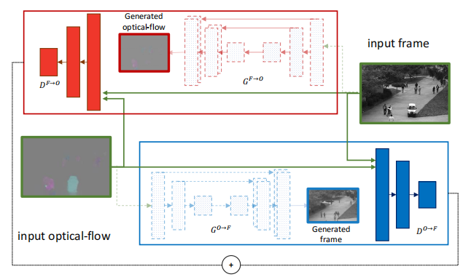

Given a test frame *F* and its corresponding optical-flow image *O*, they apply the two patch-based discriminators on the same 30 x 30 grid used for training.

**Note that we do not need to produce the reconstruction images to use the discriminators.** For instance, for a given position on the grid, ${\hat{D}}^{F→O}$ takes as input a patch $p_{F}$ on *F* and a corresponding patch $p_{O}$ on *O*. A possible abnormal area in $p_{F}$ and/or in $p_{O}$ corresponds to an outlier and results in a low value of ${\hat{D}}^{F→O}\left(p_{F},p_{O}\right)$.

They first fuse the channel-specific score maps and then apply a range of confidence thresholds on the final abnormality map to obtain different ROC points.

Two score maps: $S^{O}$ and $S^{F}$. The two score maps are summed with equal weights:

$$S=S^{O}+S^{F}$$

The values in *S* are normalized in the range [0, 1].

For each video *V*, they compute the maximum value $m_{S}$ of all the elements of *S* over all the input frames of *V*. For each frame, the normalized score map:

$$N\left(i,j\right)=\frac{1}{m_{S}}S\left(i,j\right),i,j∈\left\{1,…,30\right\}$$

Finally, they upsample *N* to the original frame size $\left(N^{'}\right)$ and the previously computed optical-flow *O* is used to filter out non-motion areas, obtaining the final abnormality map:

$$A\left(i,j\right)=\left\{\begin{matrix}1-N^{'}\left(i,j\right) if O\left(i,j\right)>0 \\ 0 othersise.\end{matrix}\right.$$

Frame-level evaluation:

An abnormality label is predicted for a given test frame if at least one abnormal pixel is predicted in that frame. The evaluation procedure is iterated using a range of confidence thresholds in order to build a corresponding ROC curve. In their case, these confidence thresholds are directly applied to the output of the abnormality map *A* defined in previous equations.

Pixel-level anomaly localization:

A test frame is a true positive if the area of the predicted abnormal pixels overlaps with the ground-truth area by at least 40%, otherwise the frame is counted as a false positive.